**The PACE Stages**

So far, you have been introduced to the PACE framework and learned how it provides a clear foundation and structure for data analysis projects. You also learned that PACE is an acronym; each one of the letters represents an actionable stage in a project: plan, analyze, construct, and execute. In this reading, you will learn more about the PACE workflow and discover how each stage of the process can help guide data analysis.

**Why do we use a workflow structure?**

As a general rule, data professionals rely on workflow structures to guide them through the duration of data projects. Within a large-scale project, there can be a number of tasks that require a certain order of operations. Identifying complexities and finding consistent ways to work together can make projects more efficient and enable more productive communication. Identifying these and other types of potential blockers early can help you plan and prepare resources in advance before they can negatively affect a project.

Our team of data professionals who assisted in creating this program developed PACE as a flexible model; you are encouraged to revisit each stage without interrupting the entire workflow. Through PACE, you will identify areas of action and contexts for when they will need to be considered. All in all, PACE offers professionals a customizable scaffold that can support their efforts while working through every stage of a data project.

**A closer look at the PACE model**

Let’s take a closer look at each stage of the PACE model.

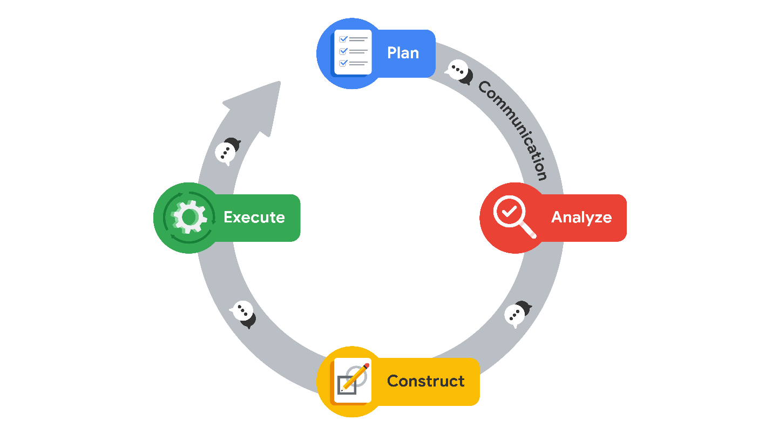

**Plan**

At the beginning of a project, it is important to establish a solid foundation for success. Here you will define the scope of your project. This is when you will begin by identifying the informational needs of the organization. During the planning stage, you will have the widest viewpoint of a project. By assessing all of the factors and processes involved, you are mapping a path to completion, using your creativity to conceptualize a course of action. Here you will also take special note of tasks that may require an innovative approach within your workflow.

**Summary**: The planning stage is where you conceptualize the scope of the project and develop the steps that will guide you through the process of completing a project.

Here are a few examples of the types of planning stage tasks:

* Research business data
* Define the project scope
* Develop a workflow
* Assess project and/or stakeholder needs

**Analyze**

In the analyzing stage, you will interact with the data for the first time. Here you will acquire all of the data you will need for the project. Some datasets could come from primary sources within your organization. Others may need to be collected from secondary sources outside your company. You may even find that you need governmental or open source data. The analyzing stage is also where you will engage in exploratory data analysis or EDA. This involves cleaning, reorganizing and analyzing all of the necessary data for the project.

**Summary**: The analyzing stage is where you will collect, prepare, and analyze all of the data for your project.

Here are a few examples of the types of analyzing stage tasks:

* Format database
* Scrub data
* Convert data into usable formats

**Construct**

Just as the name suggests, the construction stage is all about building. In this stage of PACE, you will be building, interpreting, and revising models. Some projects will require machine learning algorithms to uncover correlations within your data. You will use these correlations to uncover information from the data that would otherwise go unused. These relationships can help your organization make informed decisions about the future.

**Summary**: In the construction stage you will build models that will allow you access to hidden relationships locked within data.

Here are a few examples of the types of construction stage tasks:

* Select modeling approach
* Build models
* Build machine learning algorithms

**Execute**

In the execution stage, you will put your analysis and construction into action. Here you will deliver your findings to the internal (inside of your organization) and external (outside of your organization) stakeholders. Quite often, this will involve stakeholders from the business-side of the companies you are working with. Presenting your findings is only a part of the execution stage. Stakeholders will provide feedback, ask questions, and make recommendations that you will collect and incorporate.

**Summary**: In the execution stage you will present the finding of your analysis, receive feedback, and make revisions as necessary.

Here are a few examples of execution stage tasks:

* Share results
* Present findings to other stakeholders
* Address feedback

**Communication and PACE**

Regardless of where you might be within the PACE workflow, communication is essential to moving the framework through to the realization of the project. One way to think of this is by visualizing the four stages of PACE as a completed circuit and with communication being represented by the flow of electricity.

At each stage, there will always be a need for communication to improve the workflow. This could be asking questions about your data, gathering additional sources, updating stakeholders on progress, or presenting findings and receiving feedback.

**Adaptability of PACE**

At the start of a project, the PACE model offers a good structure to guide you. At the beginning, you have the planning stage, where you gather the information and tools you will need and set up a framework to guide you. When you are analyzing data and constructing models, the analyzing and construction stages assist you. After these steps, the execution stage is where you share results and gather feedback.

Although the PACE model is first presented as stages in a certain order, you will discover that the open flow of communication allows you to easily move to the stages you need. New information and feedback can be incorporated at any part of the process. You might need to return to the analyzing stage to clarify some aspect of the data and then go to the executing stage to present this aspect to your stakeholders, without the need to construct new models. The PACE framework can be adapted to fit any project. Its adaptability will prepare you for a dynamic profession that requires a high degree of professional flexibility and communication.

**Key takeaways**

Data professionals need structured workflows to help them manage the large number of tasks within data projects. The PACE professional workflow was designed specifically for this program to assist you in developing your professional structures and practices. PACE functions like a completed circuit, with communication flowing between each stage. The design of PACE promotes flexibility, allowing for free movement between stages as needed.